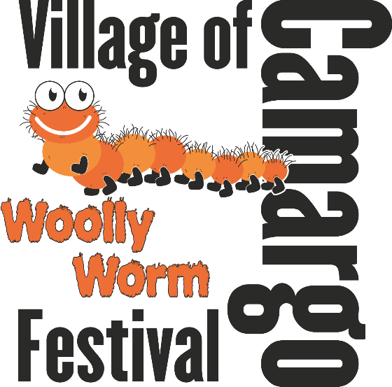

LIVE

ENTERTAINMENT

Smoke N Whiskey

Mackville

Kathy Hardin

Whiskey River

Garrett & The Geezers

VG Dance Teams

VG Cheer Squads

Saturday, October 06, 2018

6 am – 11 pm

FAMILY FUN

5K, Art in the Park, Kiddie Tractor Pulls, Woolly Worm Races, Coloring Contest,

King & Queen,

Bake Off, Grill Off, Inflatables, Shopping, and so much more!

CAMARGO’S INAUGURAL

CAR SHOW

FOOD VENDORS

Charleston Concessions

VG FFA

Birgeys

2nd ANNUAL GLOW CART PARADE

Bring your golf cart, go carts, and ATVs! Decorate them up and join us for a glowing good time! This is a free event for participants and spectators.